ALM To Rally Defects Migration through ConnectALL

Contents

Clone Existing Automation: 2

1. ConnectALL Access. 2

2. Clone the existing Automation. 3

3. Update Field & Entity Mappings 4

4. Automation Scripts Association 13

5. Automation Execution 14

6. Error handlings 18

Appendix 22

One-Time request for access to ConnectALL: 22

|  |  |  |  |
| --- | --- | --- | --- |
| Author(s) | Version | Published Date | Modified |
| Venkat Bhupathi | 1.0 | 02/23/2024 | Initial version |
| Venkat Bhupathi | 1.1 | 03/06/2024 |  |

Defect Migration Automation:

**Clone Existing Automation:(**Use existing Automation with required changes)

Following steps for cloning the existing Automation

* Login to ConnectALL
* Clone the existing Automation.
* Update exiting Mappings (Field & Entity)
* Automation script Association

# Clone Existing Automation:

## Log-into ConnectALL

## Note: ConnectAll Access – See Appendix for details

By using below URL login to ConnectALL

<https://connectall.broadcom.com/ConnectAll/login.jsp>

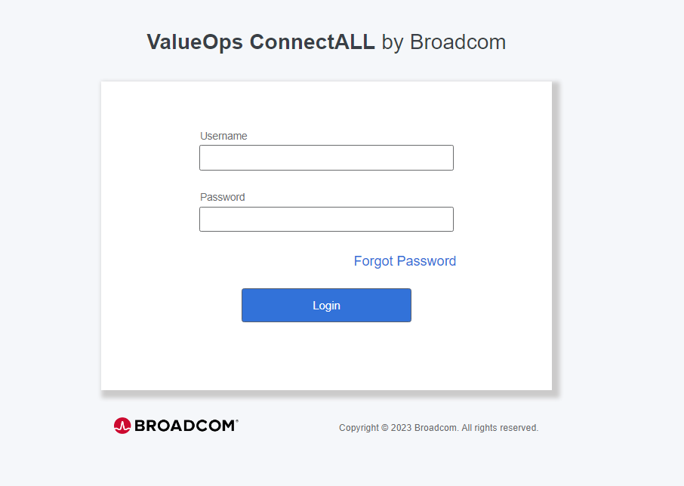

## Clone the existing Automation.

Select suitable existing automation for migrating defects from ALM using Cloning process.

Click on Automations

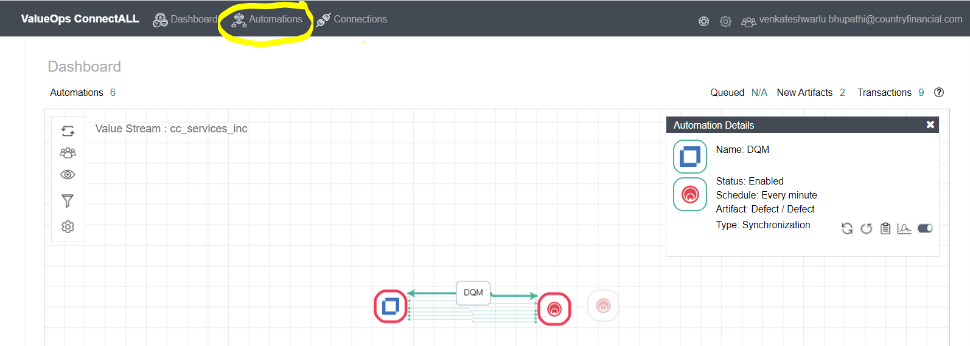

select cloning Automation (ex. DQM)

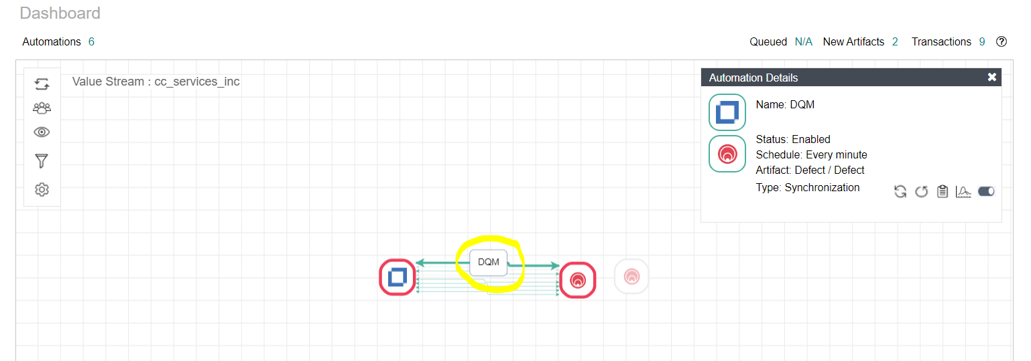

Click on clone Icon at right corner.

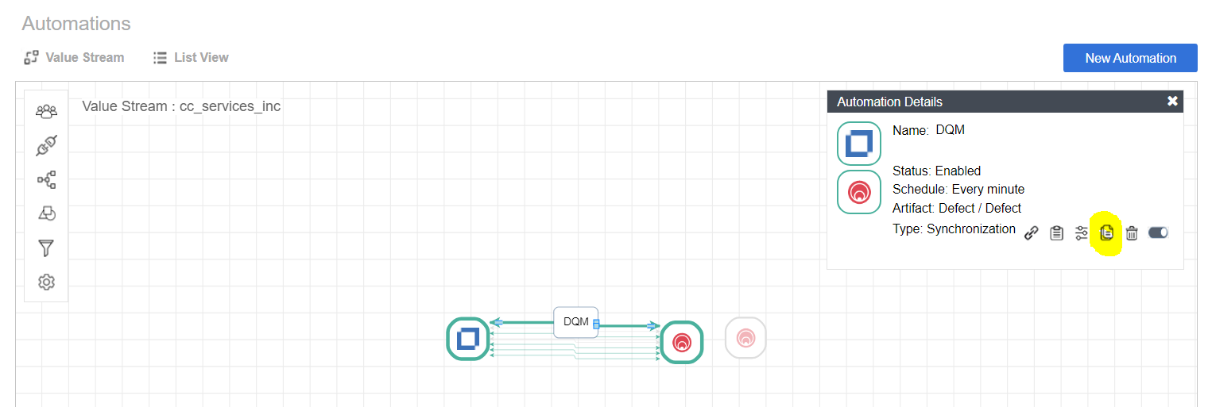

Enter new Automation Name & Click on Clone

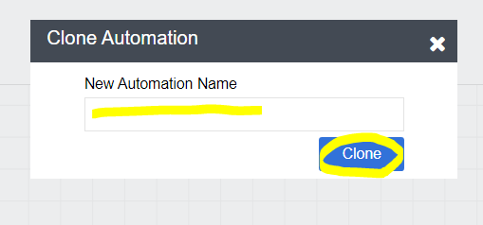

## Update Field & Entity Mappings

Select DEA & Click on modify icon at right corner box.

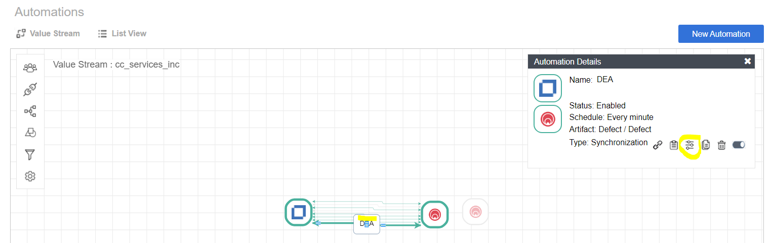

Select **Entity mapping** and update the below highlighted fields as per new project requirement.

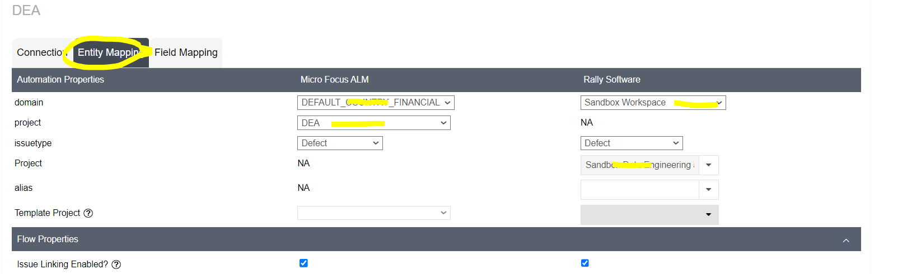

Update filter as per project requirement.

Existing filter is used for migrating “not closed” defects from ALM.

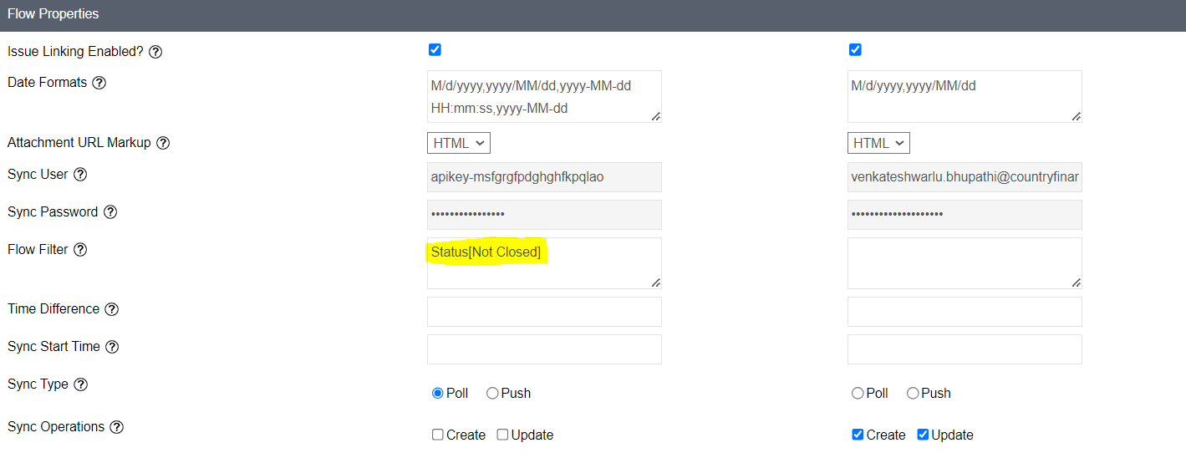

Filters: Please follow the below steps to create filters (based on your requirement add filters, in below example I have included two filters)

1. Login to ALM
2. Select Defects

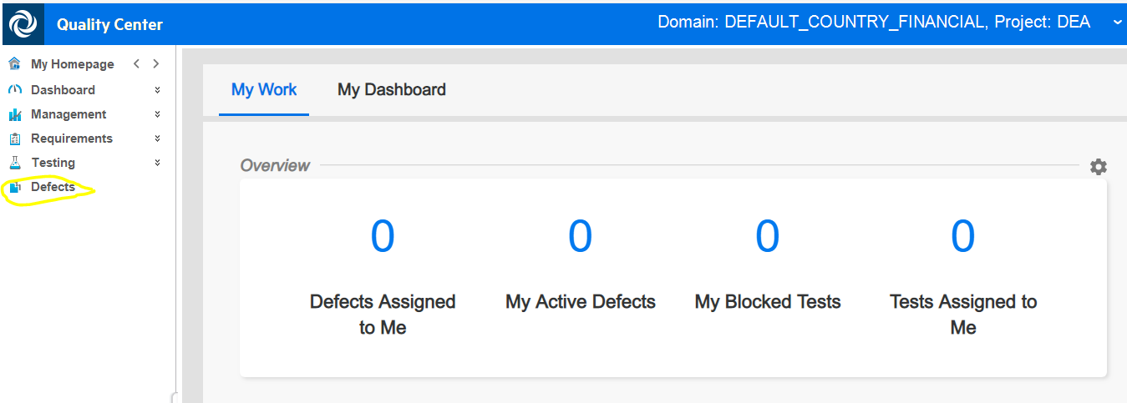

Apply first filter(Not closed defects)

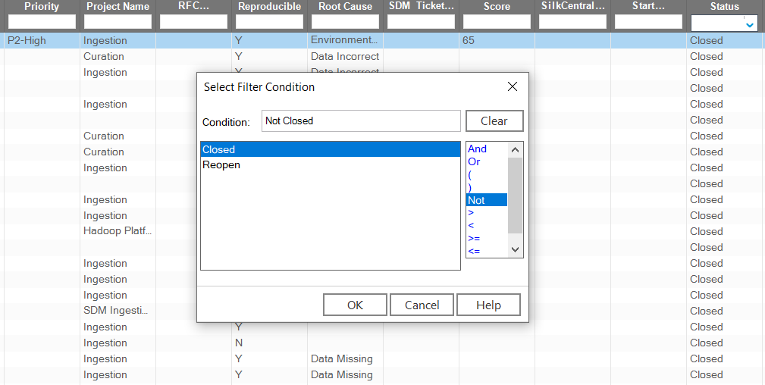

Apply second filter(Only support team defects)

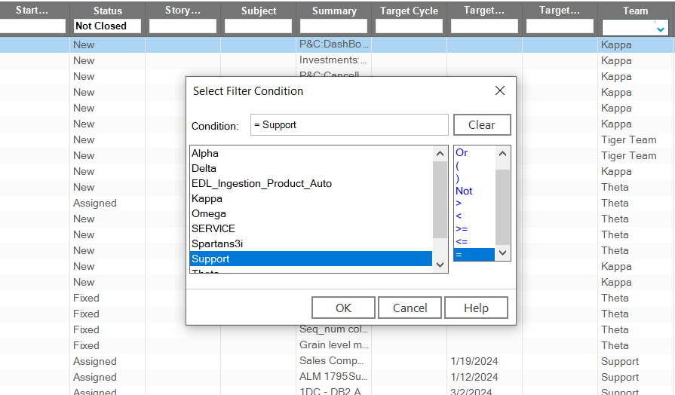

1. Copy/Type filters from ALM (Below highlited)

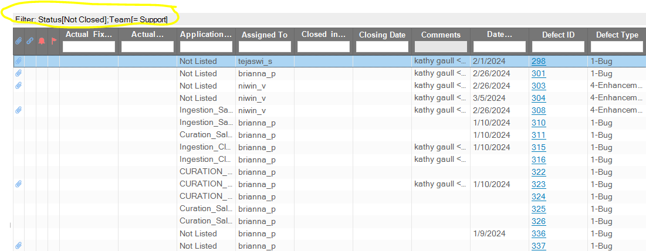

1. Paste into Flow Filter field in ConnectALL

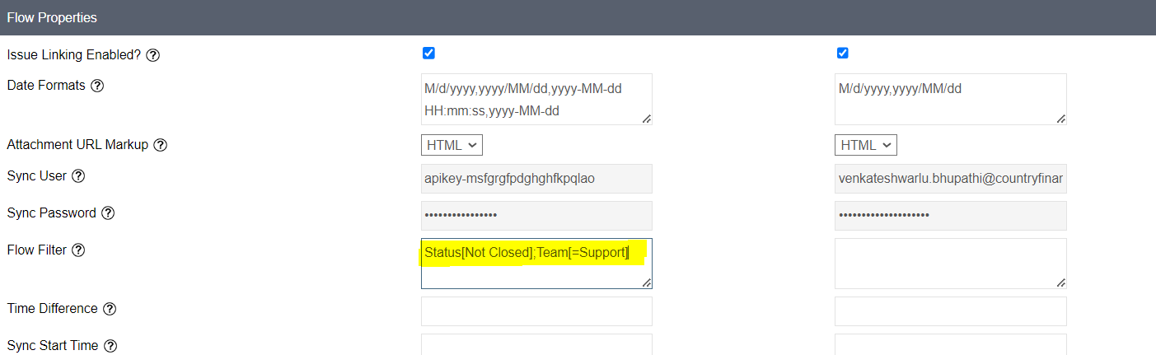

Update **Field Mapping** as per project requirement.

Get the field mapping details from the Mapping document (in below path)

<https://countryfinancial.sharepoint.com/sites/TCoEDepartment/Shared%20Documents/Forms/AllItems.aspx?cid=45e4b69d%2D4b03%2D4985%2Da834%2Dc4054b850f68&RootFolder=%2Fsites%2FTCoEDepartment%2FShared%20Documents%2FRally&FolderCTID=0x012000E7BC6F51275C104788BDB29AF974A2A1>

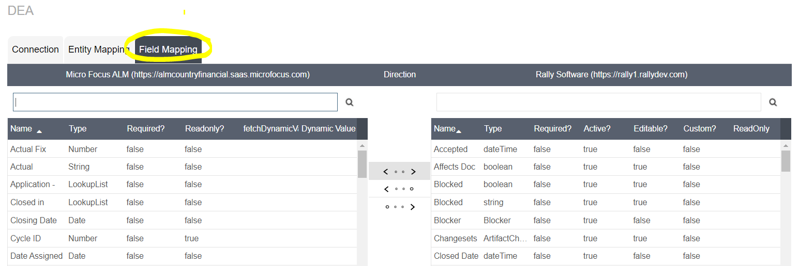

Update field values as per project requirement.

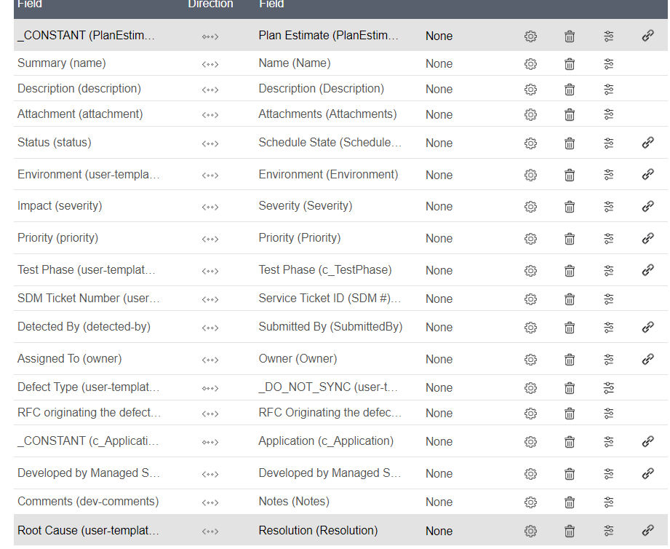

Ex.

* Map ALM Status field to Status field in Rally.

Click on Hamburger icon to edit.



Map the values.

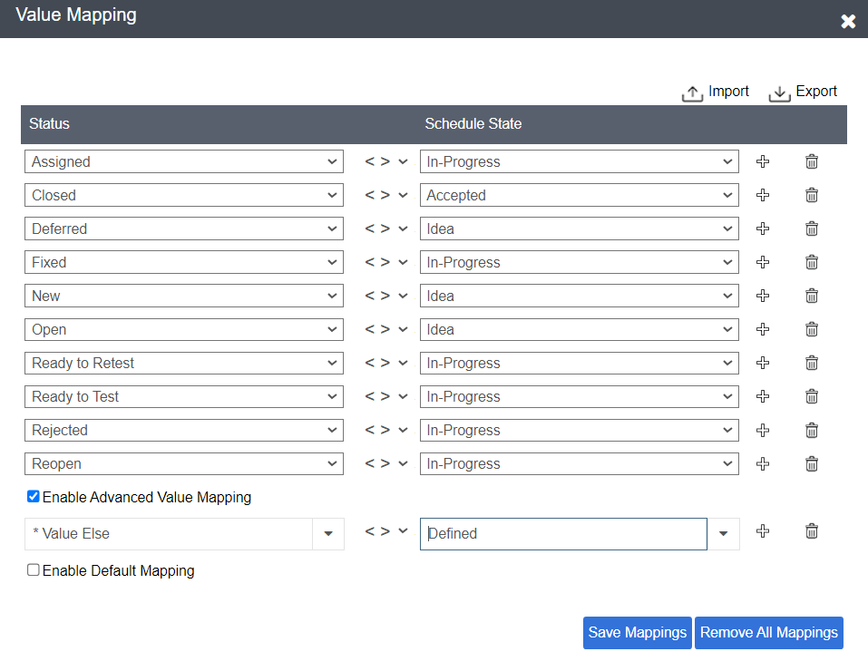

“Enable Default mapping” check box is used to Map to “Defined” Status if any field is other than the mapped values. (ex. Defined is default status)

* Map ALM Detected by ALM field to Submitted By field in Rally.

Map the users as in the below screenshot.

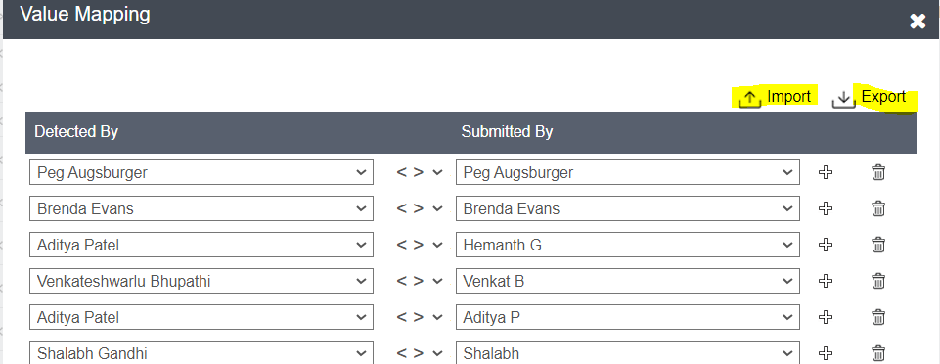

Sometimes all users are not available in that case we need to prepare .CSV file by exporting sample file then update with all users (like attached sheet) and import.

Ex.

* Map ALM Root Cause field to Resolution field in Rally.

Steps: 1. Delete existing mapping by click on delete icon

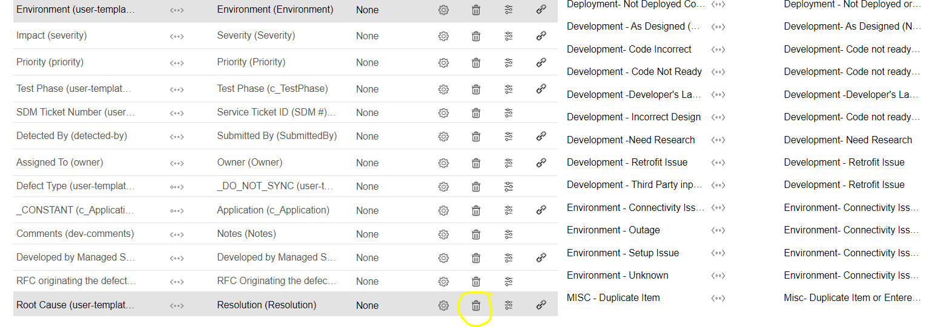

2. Map again (Root cause 🡪 Resolution) and click on edit icon

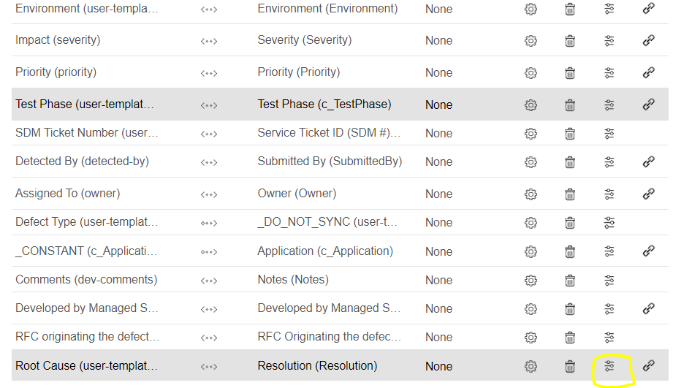

3.Import ConnectALl_Rootcausemapping.csv file from the below location.

<https://countryfinancial.sharepoint.com/sites/TCoEDepartment/Shared%20Documents/Forms/AllItems.aspx>

Ex. 

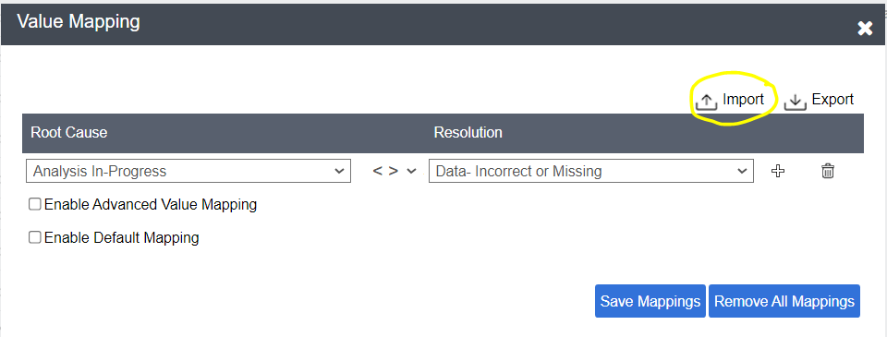

Click on OK

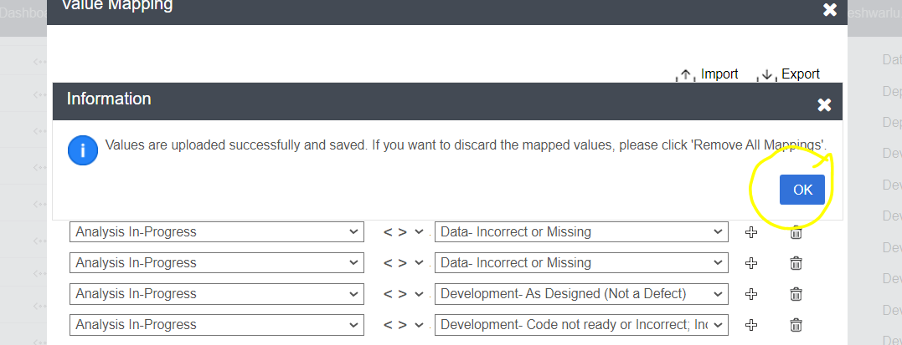

Click on X mark at window corner.

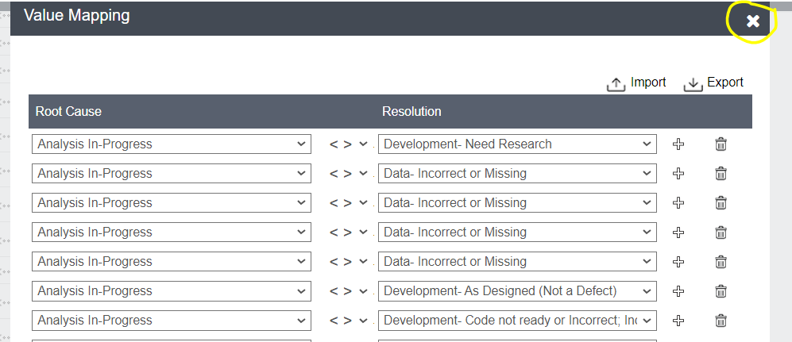

Scroll down and click on Save.

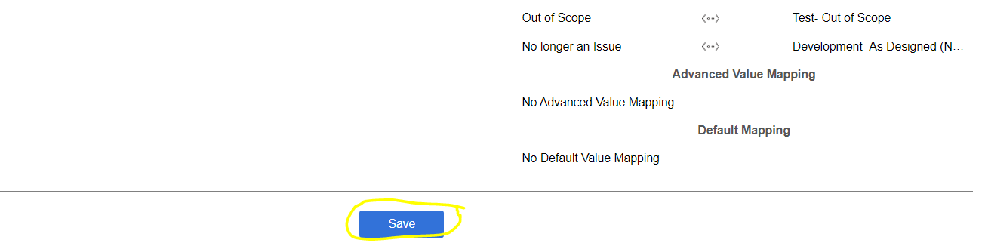

Enter Version and click on Save Mappings.

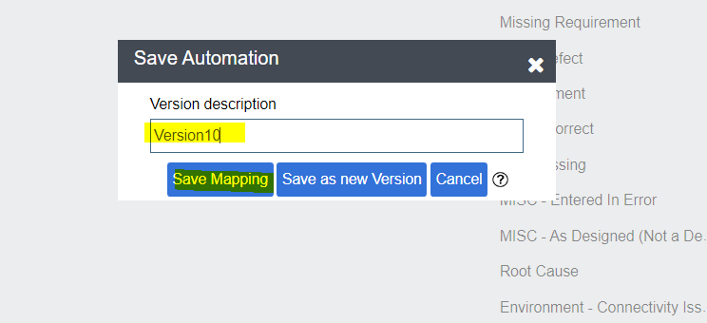

## Automation Scripts Association

Automation scripts are used to customize the fields as per requirement, these scripts are written in Groovy scripting language. We have a script for concatenating the Name field in rally this needs to be associate.

**Go to manage scripts.**

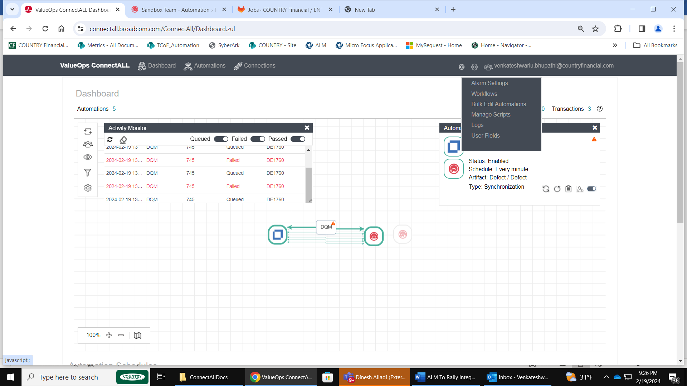

Associate Script:

Click on Associate Icon

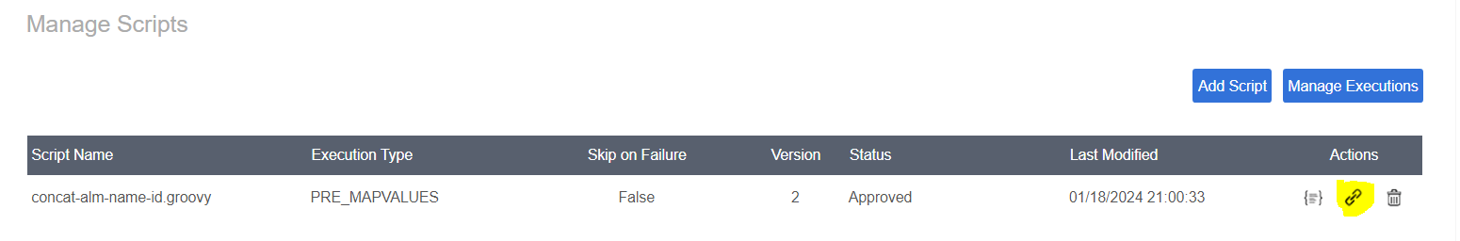

Select Automations and Save.

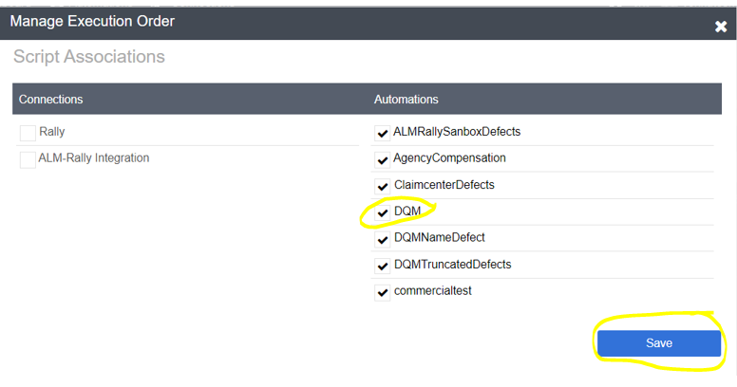

## Automation Execution

Go to Dashboard: Script execution will start from Dashboard.

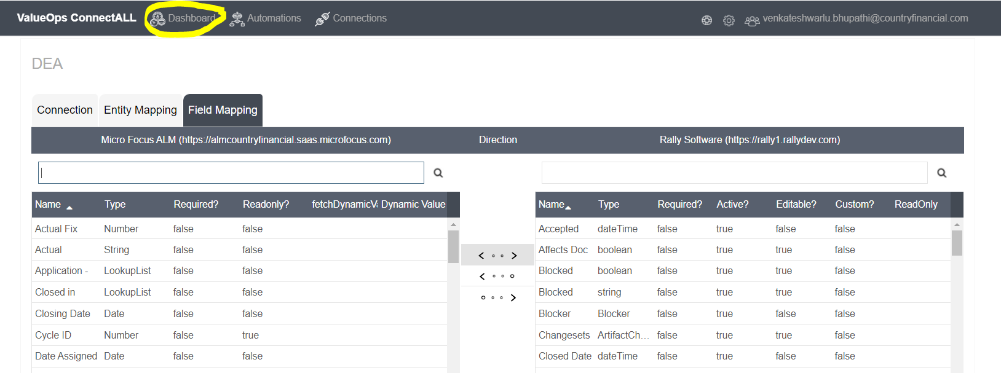

Select Automation (Ex.DQM) and click on the run icon in the right corner box.

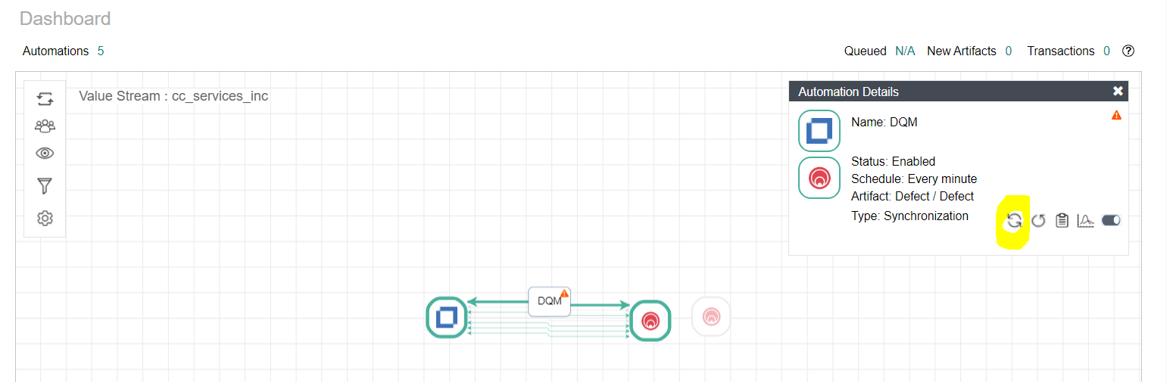

Click on the Monitor icon to view the execution details in the left corner box.

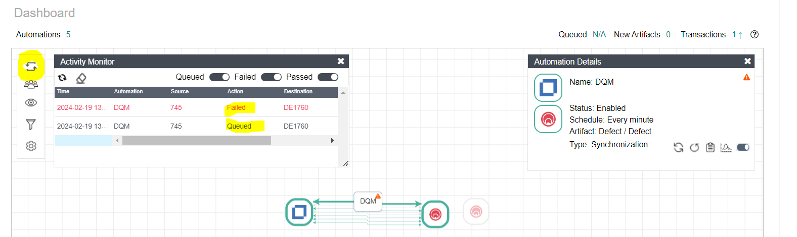

Scroll down the page to verify the failed results.

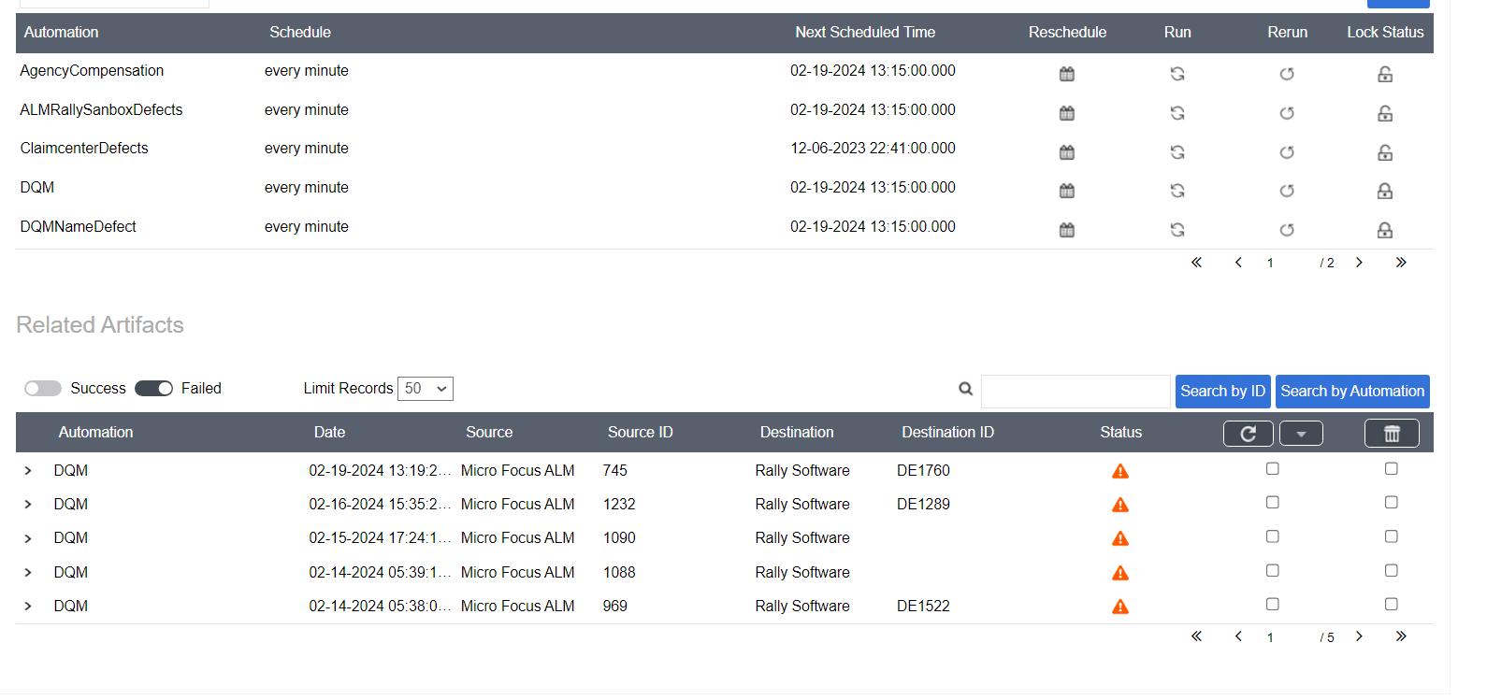

Enter failed defect id in Search field click on Search by ID button.

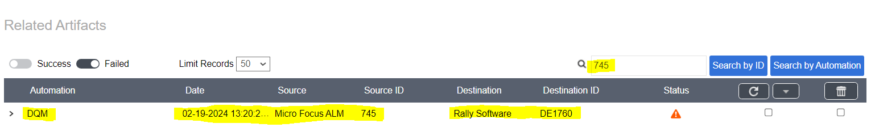

Click on > icon to find the failed reason.

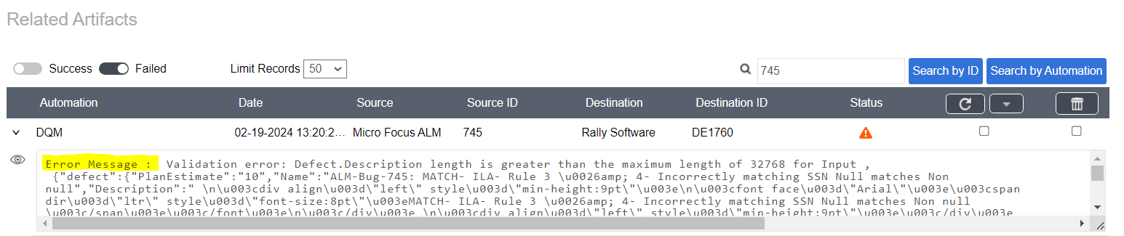

Resolve the issue and rerun the Automation.

Select check box and click on the retry button.

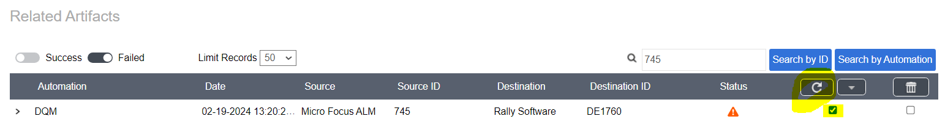

**Full run:** By using rerun option all the defects will re-execute to a particular selected time of period.

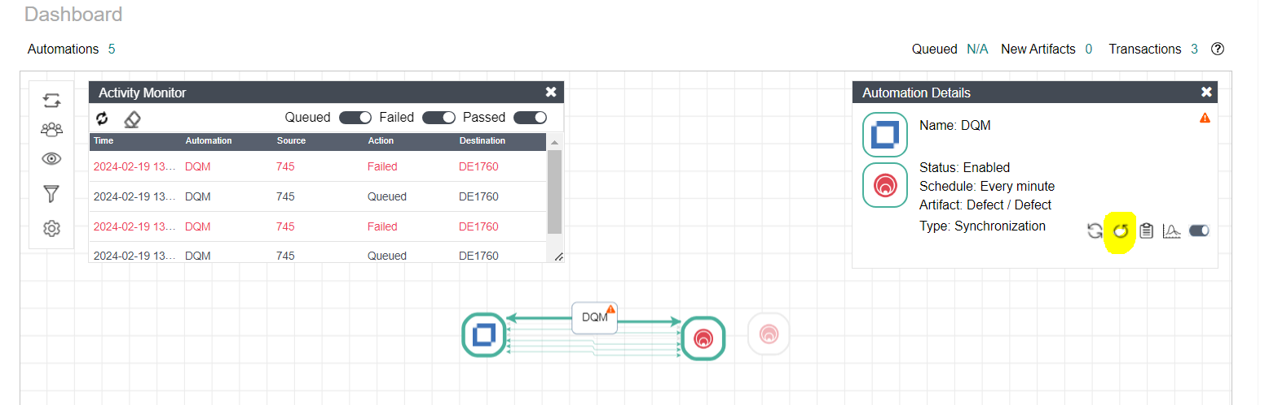

Sync Start Time: Enter time from where we need to synchronize the defects in ALM.

Select - Full sync.

Click on Save

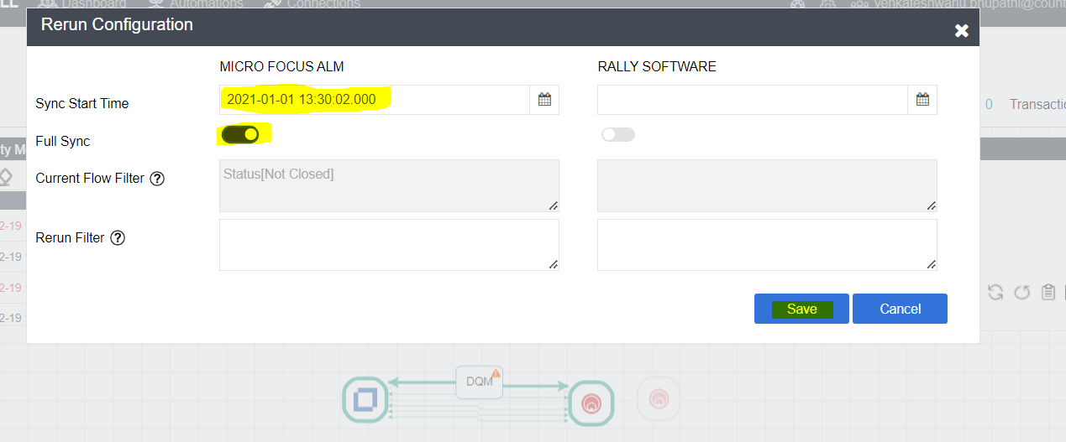

Monitor the rerun details.

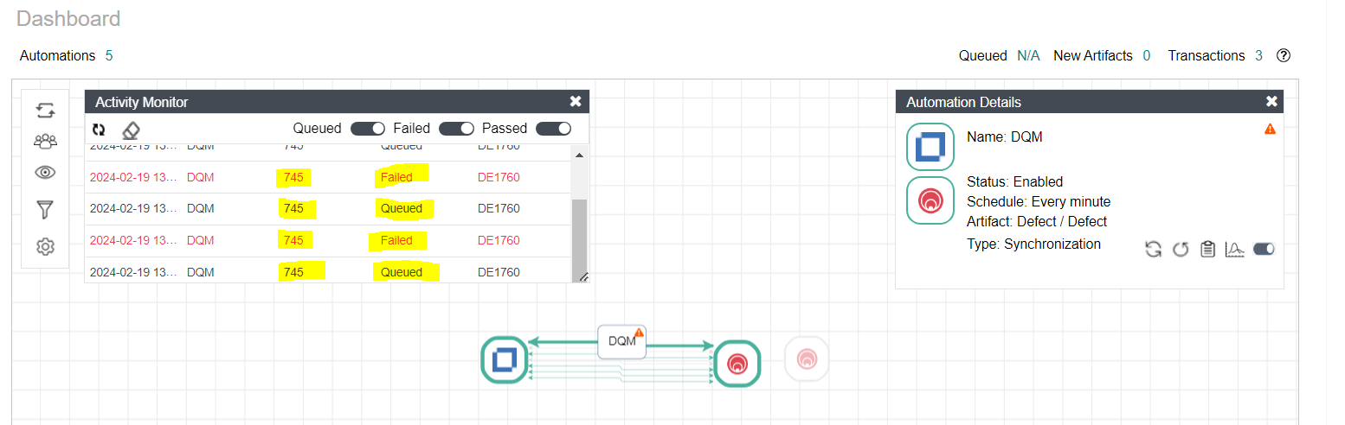

## Error handlings

While doing POC we have observed below major errors

1. Description and Name too long:

We are observing the error below because Description & Name are too long in ALM which exceeds field size limit in Rally.



Solution:

Identify the same issue defects and create separate Automation and in Field mapping Description & Name field values Mapp it to _CONSTANT.

Entity Mapping: Filter for selected defects

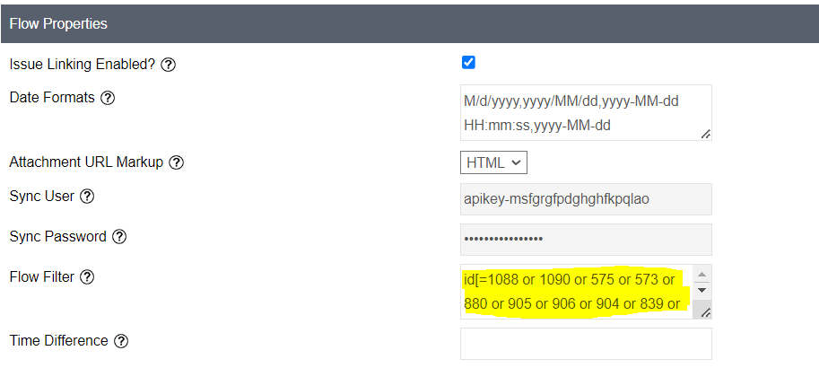

Field Mapping:

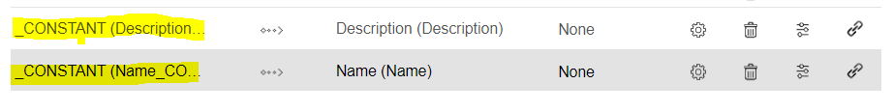

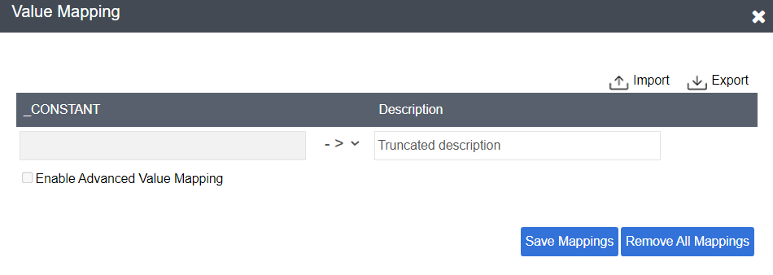

Description and Name fields we must update manually in Rally.

1. Developed by Managed services:

We are observing the error below (in screenshot) because the values developed by managed services are incorrectly mapped.

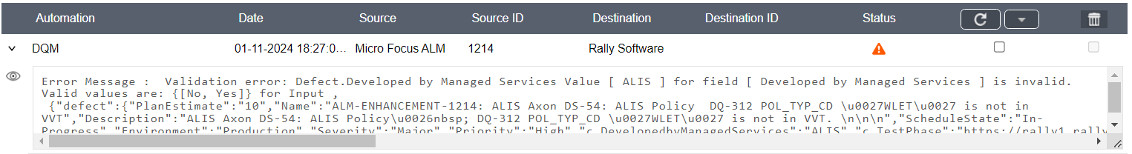

Solution:

Go to Field mapping 🡪select edit button for Developed by managed services and Mapp values like below screenshot.

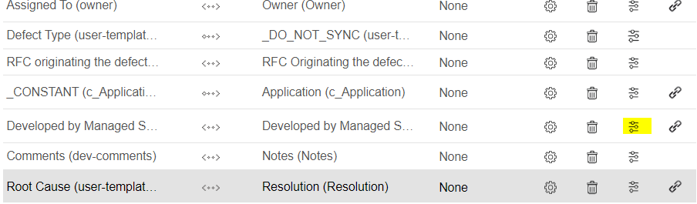

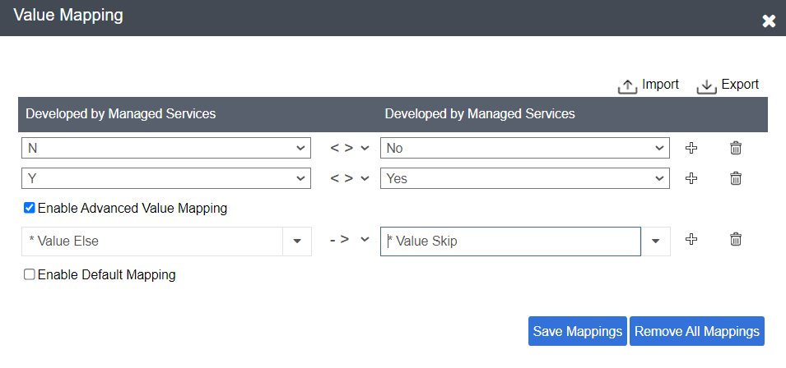

1. Resolution field mapping error:

We have observed below error because mapping value is not exactly same as Rally value (in Resolution drop down)

There is some space and typo issue.

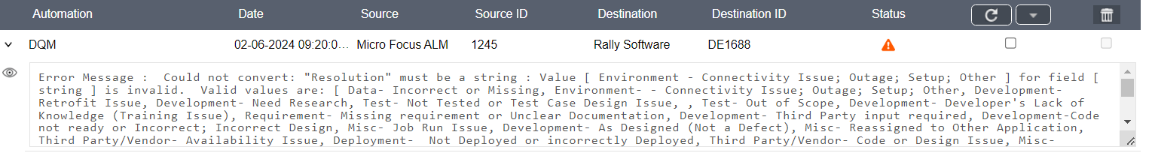

Solution:

From the above Error message [Environment – Connectivity Issue; Setup; Other] there is extra space in between Environment and Connectivity, remove the space and reupload CSV file in field mapping.

Note: If we are getting any errors or issues other than these, we need to contact Rally support team

Contact details:

Sharath - [sharath.bhaskara@broadcom.com](mailto:sharath.bhaskara@broadcom.com)

Mickey - micky.holmes@broadcom.com

# Appendix

# One-Time request for access to ConnectALL:

Contact Rally team to get the credentials for ConnectALL.

Contact details:

Mickey - micky.holmes@broadcom

Sharath - [sharath.bhaskara@broadcom.com](mailto:sharath.bhaskara@broadcom.com)